Lab Number: | 3
Student Name: | Rishi Dubey
Roll No : | 29

Title:
Write a C++ program to Create a class Student with two method getData() and printData(). getData() to get the value from the user and display the data in printData(). Create the two objects s1 ,s2 to declare and access the values from class StudentTest.
Write a C++ program for Basic bank Management System

Learning Objective:
    - Students will be able to write C++ and java program for using classes and objects.

Learning Outcome:
      - Ability to execute a simple C++and Java program by accepting and displaying values using functions
      - Understanding the classes and objects concept in C++ and Java.

Course Outcome:

ECL304.1 | Understand object-oriented programming concepts and implement using C++ and Java

Write a C++ program to Create a class Student with two method getData() and printData(). getData() to get the value from the user and display the data in printData(). Create the two objects s1 ,s2 to declare and access the values from class StudentTest.

#include<iostream> using namespace std; class Student {
public: string name; int roll_no; float cgpa; char div;
string branch;

void getdata()
{
cout<<"Enter your name:"<<endl; cin>>name;
cout<<"Enter your roll number:"<<endl; cin>>roll_no;
cout<<"Enter your CGPA:"<<endl; cin>>cgpa;
cout<<"Enter your Division:"<<endl; cin>>div;
cout<<"Enter your branch:"<<endl; cin>>branch;

}

void getdata(string n,int r,float c,char d,string b)
{
name=n; roll_no=r; cgpa=c; div=d; branch=b;

}

void printdata()
{
cout<<"Name of the student: "<<name<<endl; cout<<"Roll-no of the student: "<<roll_no<<endl;
cout<<"Cgpa of the student: "<<cgpa<<endl; cout<<"Division of the student: "<<div<<endl; cout<<"Branch of the student: "<<branch<<endl;
}

};

int main ()
{
Student s1; Student s2;

s1.getdata(); s1.printdata(); s2.getdata(); s2.printdata(); return 0;
}

Write a C++ program for Basic bank Management System
#include<iostream> using namespace std;

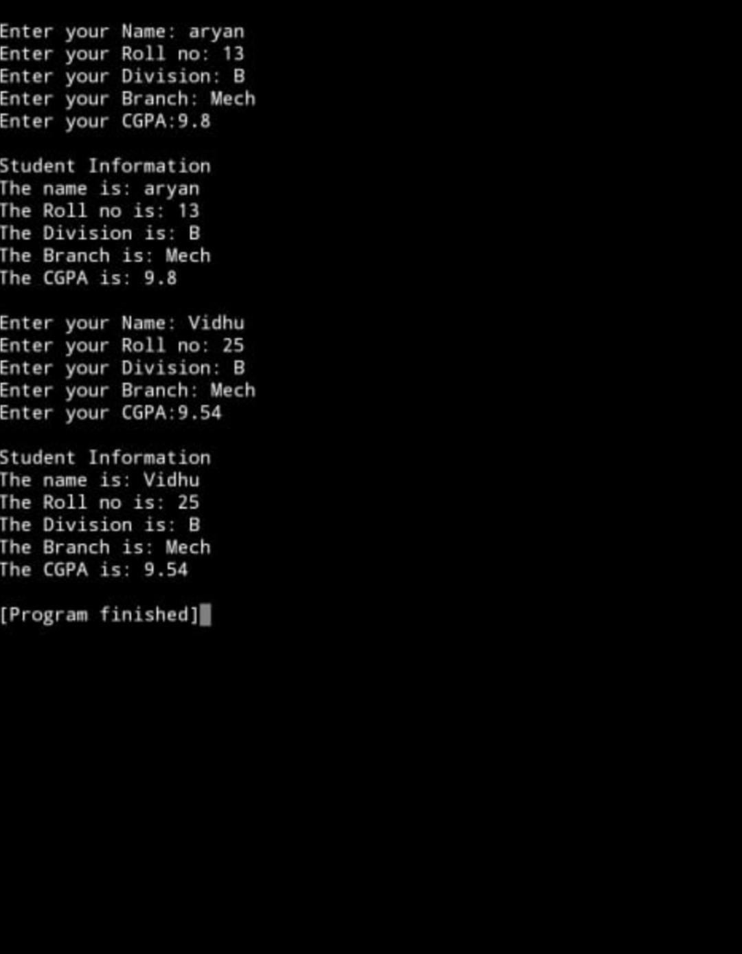

class BankLab2 {

public:

string name;

char account_type;

int account_number,amount;

float balance;

BankLab2(string n,int a, char t, float b) {

name = n;

account_number=a;

account_type=t;

balance=b;

}

int deposit()

{

cout<<"Enter the amount to deposit: ";

cin>>amount;

if(amount<0)

{

cout<<"Invalid amount,Enter a valid amount";

return 0;

}

balance=balance+amount;

return 1;

}

int withdraw()

{

cout<<"Your Balance= "<<balance;

cout<<"Enter amount to withdraw: ";

cin>>amount;

if (balance<amount)

{

cout<<"Insufficient Balance: ";

return 0;

}

if(amount<0)

{

cout<<"Invalid amount";

return 0;

}

balance=balance-amount;

return 1;

}

void display()

{

cout<<"Name :"<<name;

cout<<"Account Number:"<<account_number;

cout<<"Account Type:"<<account_type;

cout<<"Balance: "<<balance;

}

};
int main()
{

int account_number; char ans;

BankLab2 b1("salman",1,'s',2000);

BankLab2 b2("makarand",2,'s',2000);

BankLab2 b3("siddharth",3,'s',2000);

cout<<"Menu"<<endl;

cout<<"1.Deposit"<<endl;

cout<<"2.Withdraw"<<endl;

cout<<"3.Display"<<endl;

cout<<"Enter option"<<endl;

int op;

cin>>op;

do

{

cout<<"Please enter your account number:"<<endl;

cin>>account_number;

switch(account_number)

{

case 1: if(op==1)

b1.deposit();

if(op==2)

b1.withdraw();

if(op==3)

b1.display();

break;

case 2: if(op==1)

b2.deposit();

if(op==2)

b2.withdraw();

if(op==3)

b2.display();

break;

case 3: if(op==1)

b3.deposit();

if(op==2)

b3.withdraw();

if(op==3)

b3.display();

break;

default: cout<<"Enter value between 1 to 3";

break;

}
cout<<"Do you want to continue?[Y/N]";

cin>>ans;

if(ans=='Y' || ans == 'y')

{

cout<<"Menu";

cout<<"1.Deposit";

cout<<"2.Withdraw";

cout<<"3.Display";

cout<<"Enter option";

cin>>op;

}

}

while(ans!='N');




